Argyll and the Islands LEADER Programme Evaluation

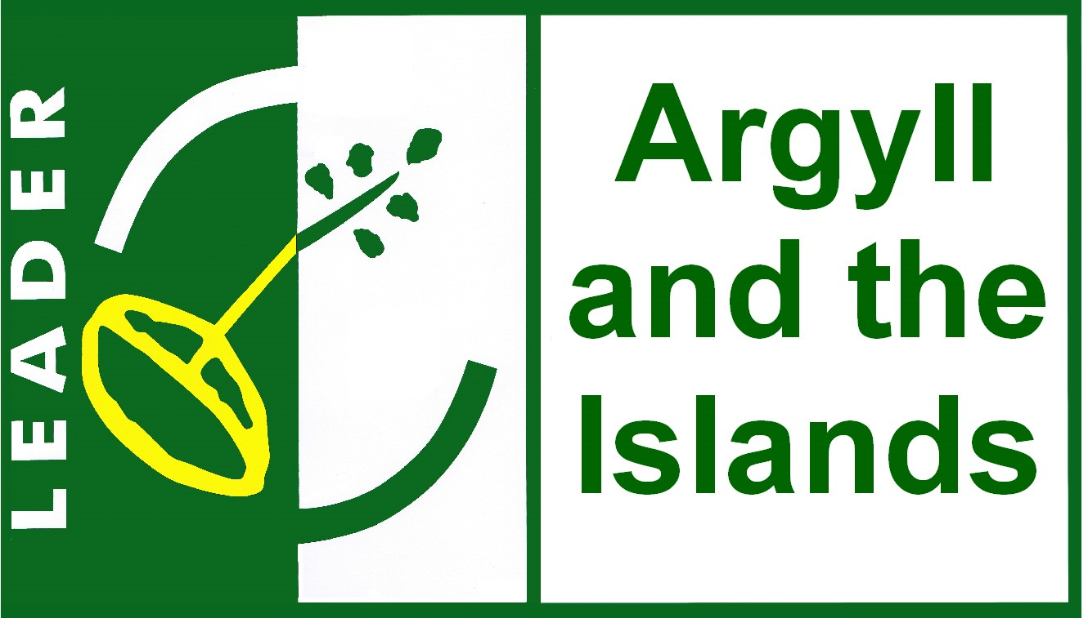
Client: Argyll and the Islands LEADER Local Action Group (LAG)
Project Description: The Argyll and the Islands LEADER programme, aligned with Scottish Government policy for rural development, sought to support local rural communities and businesses. The project's goal was to secure crucial funding for the region by creating a Local Development Strategy (LDS) that would demonstrate the programme's clear contribution to EU strategy. The client needed an evidence-based, well-structured plan to effectively identify community needs and prioritise investments, ultimately ensuring the continued success and legacy of the LEADER programme.
Method Undertaken: While Director of Hall Aitken I was commissioned to develop the LDS. The methodology was comprehensive and collaborative, beginning with the co-design of a logic model that focused on priority outcomes. The team undertook extensive desk research, analysing existing data from the LARCS system and other sources to understand the programme’s outputs and results. They also conducted primary research, including a survey of 33 projects and numerous semi-structured interviews with programme staff, LAG members, and key stakeholders. Community workshops were held to gather views and ensure the strategy was built on the needs and perspectives of the local population.
Findings and Outcomes: The robust, evidence-based strategy created was successfully submitted to the Scottish Government and was approved. The process helped the LAG to effectively prioritise investments, ensuring that funding was directed towards genuine community needs and strategic objectives. A key finding was the importance of effective integration and alignment of support and services across different areas. The report successfully demonstrated the programme's value, highlighting its impact on strengthening the local economy and enhancing services and facilities.
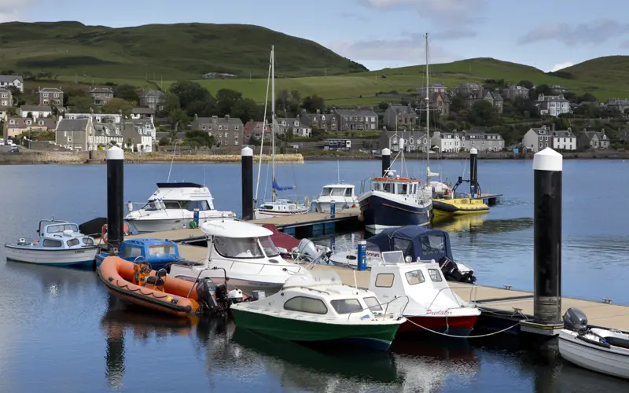
Benefits: The project provided a clear, evidence-based roadmap for the LAG, leading to the successful approval of the funding. By empowering local communities and stakeholders through a collaborative process, the project built stronger partnerships and improved the understanding of what works, creating a lasting framework. The resulting strategy and report serve as a vital tool for showcasing the positive impact of the LEADER programme.

Uist Repopulation Action Plan Community Consultation


Client: Comhairle nan Eilean Siar
Project Description: While a Director of Hall Aitken I was asked by the council to manage a consultation of the community and stakeholders of Uist to share their views on the draft plan for Uist Repopulation Action Zone. Their views were sought on housing, jobs, infrastructure services ,attracting talent and the Gaelic culture and language.
Method Undertaken: The consultation was promoted through leaflets in community halls, notices in local newspapers and coverage on the local radio as well as on social media. People were asked to give their views on an online survey. In addition a number of stakeholders were interviewed and six community consultation events were advertised and the groups at the focus groups gave their views.
Findings and Outcomes: The consultation showed that Housing is the key priority. Many potential residents face challenges finding housing even if they secure a job on the island. There is a concern that second homes and holiday lets are restricting the housing market. Various types of housing are needed, and young people require financial support to purchase homes. The complexity of crofting was frequently discussed.
Jobs are not a major issue; there are many available positions on Uist but a Island Skills Training scheme could help increase the number of tradespeople.
The poor state of roads and the ferry system are major concerns. Improved bus networks, digital connectivity, and a community electricity network are necessary. The unpredictability and cost of the air and, especially, the ferry services are impacting upon people’s livelihoods. Adequate access to NHS, schools, childcare, and shops is crucial for making the island attractive to current and potential residents.
Messages promoting Uist should highlight job opportunities, safety, good schools, healthy lifestyles, great food produce, and proximity to Scottish cities. The community emphasised the importance of Gaelic and suggested it be central to the repopulation strategy.

Benefits: Following receipt of the consultation report the Uist Repopulation Zone Working Group are committed to the delivery of an updated Plan and, whilst some actions can be delivered immediately, they are dedicated to influencing policy and procedural change to make Uist an attractive, sustainable, active and connected place to live whilst also retaining and protecting its unique qualities that entice people to stay.

