Hermitage Park Improvement Evaluation
Client: Argyll and Bute Council
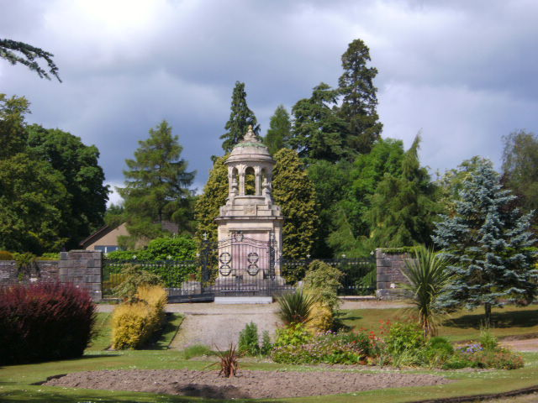
Project Description:
Hermitage Park, Helensburgh’s only urban park, had suffered years of decline. With £3.7m from the National Lottery Heritage Fund and other partners, Argyll and Bute Council led a major regeneration to restore heritage features, improve facilities, and create a vibrant community space.
Method Undertaken:
While a Director of Hall Aitken I designed an evaluation using baseline consultation data, visitor surveys, volunteer feedback, and stakeholder interviews. Comparative analysis against agreed NLHF outcomes and national Green Flag standards provided a robust framework.
Findings:
The park delivered significant heritage, social, and environmental benefits. Visitor numbers increased, heritage assets were preserved, a new Pavilion enhanced community activity, and training/volunteering broadened local engagement.
Outcomes & Benefits:
The evaluation demonstrated the project’s success in revitalising a valued greenspace, strengthening community pride, and ensuring sustainable management. The Council gained clear evidence for future funding bids and national recognition of Hermitage Park as a high-quality asset.

Unlocking Ambition Evaluation
Client: Scottish Enterprise
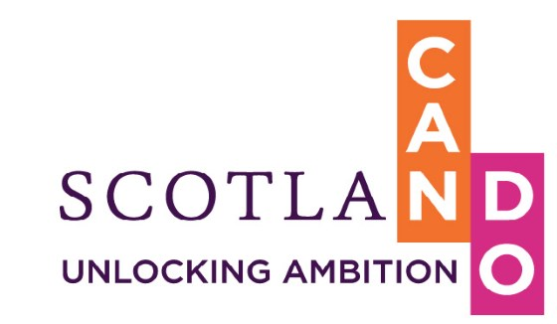
Project Description:
Scottish Enterprise commissioned an evaluation of the Unlocking Ambition (UA) programme, a flagship initiative launched in 2018 to support entrepreneurs with high growth potential. The programme provided wrap-around support including funding, mentoring, training, and networks to help businesses scale and deliver social and economic value.
Method Undertaken:
I reviewed while with Hall Aitken the completed UA1 outcomes through surveys and progress tracking, while the ongoing UA2 was assessed using online surveys, telephone interviews, and analysis of programme data. The approach compared in-person support from UA1 with online delivery in UA2.
Findings:
UA participants demonstrated tangible growth, with increases in jobs, sales, investment, and collaborations. Businesses also embedded purpose-driven values, fair work practices, and stronger leadership. Covid-19 challenges were acknowledged, but many companies reported resilience and innovation.
Outcomes & Benefits:
The evaluation evidenced that Unlocking Ambition created significant economic and social impact, positioning participants as purpose-led leaders and scaling businesses. Scottish Enterprise gained actionable insights to refine future rounds (UA3/UA4), ensuring the programme continues to drive inclusive entrepreneurship and long-term economic benefits for Scotland.

Active England
Client: Sport England
Project Description:
In partnership with National Lottery Community Fund £100m was invested in 240 projects across England to stimulate increased participation in sport and physical activity.
Method Undertaken:
Across 9 regions in England I helped each of these projects understand the outcomes they wished to achieve and how these fitted with the core outcomes of the programme. Specific Key Performance Indicators (KPIs) were outlined to project staff in a Guide to Monitoring and Evaluation. Through direct data collection through a customised data collection tool (Value Mapping), stakeholder interviews, case studies and annual conferences then qualitative and quantitative data was collected.
Findings:
Active England allowed us to identify what works for a range of thematic projects such as those using open/green space, water-based, Black and Minority Ethnic Communities, women and people with Disabilities. Annual conferences that brought together projects, staff and stakeholders were delivered in venues such as Milton Keynes Hockey Stadium and Bolton Football ground to better share learning.
Outcomes & Benefits:
Case studies that gathered the lessons learned were compiled and promoted through a programme specific website and Sport England s website. In addition, the monitoring and evaluation tools that were used by projects were made available to other projects keen to measure and report on their activities.

Evaluation of County Coaching programme
Client: Sport England
Sport England is the arms-length body of government, responsible for growing and developing grassroots sport and getting more people active across England. Its strategy, Towards an Active Nation, sets out how it works with national and local partners to ensure everyone in England can benefit from sport and physical activity.
Over an 18-month period, Sport England invested £2million in 43 County Sports Partnerships (CSPs) to implement its strategy for Coaching an Active Nation. CSPs were given the freedom to try new approaches in engaging with new audiences to broaden the appeal of coaching.
WhIle with Hall Aitken I was asked to evaluate the systemic change created by this investment and to identify how this can be sustained into the future.
Method: I carried out a full document review and then focussed on engaging with people involved in the CSPs’ activities. I conducted a web-based survey of CSP coaching contacts and 10 interviews with individuals from CSPs and Sport England. I made four visits to develop cases studies.
Finding: We identified that the investment had achieved three related areas of positive impact: greater partnership working; better community engagement and more time to learn and share. Work with non-traditional bodies helped recruit more coaches and we estimated that 18,275 additional coaches had been supported since 2016. CSP staff and stakeholders reported the programme is changing the culture, broadening the definition of coaches and increasing the emphasis on softer skills.
Outcomes and benefits: Because of our work Sport England understood the positive impacts of its initiative and investment in coaching and was able to use that evidence to inform future programmes and changes in coaching.

SROI Evaluation of Sustain Falkirk
Client: Aberlour Children’s Charity
While Director of Social Value Lab I led the evaluation. Sustain supports whole families, offering personalised support for both children and their parents. The service is delivered 7 days a week including evenings and weekends. The support offered is both emotional and practical. The service works with families and parents to secure a nurturing environment for children aged 12-18. It also supports parents, carers, and kinship carers to develop their ability to care for their children, provide practical parenting skills and help build their ability to engage with the community. The service is flexible in its intensity and aims to encourage the building of family routines, resilience and improve parental confidence. All referrals come through Falkirk Council.
Method: We used a mixed methods approach to this evaluation, We carried out a full document review and then focussed on engaging with people involved in the programmes activities. In depth interviews with families that have used the service and semi-structured interviews with key stakeholders and a survey completed by stakeholders and social workers. We carried out face-to-face and telephone interviews with Aberlour management and delivery staff and a focus group with Aberlour delivery staff
Findings: The service is achieving its objectives. The Sustain service is reaching the right children and families. Due to the well-functioning gatekeeping all service users were children at the edge of care (100%) and families in crisis. The Sustain approach of delivering flexible, intensive, whole-family support and thus addressing the root causes rather than responding to an immediate crisis situation has a positive impact on family relationships. Following SROI methods we calculated the social value delivered to Falkirk Council. For every £1 invested in this project more than £13 of social value was delivered.
Outcomes and benefits Sustain can reduce some pressure on Social Work staff, in the sense that they do not have to spend as much time on Sustain Falkirk cases freeing some time for other cases. The project delivers high value for money.

