Case Study: Development Trust Legal Structures – Highlands & Islands Enterprise (HIE)


Project Description: While with Hall Aitken I was commissioned by Highlands & Islands Enterprise to produce practical guidance for staff and community anchor organisations on the most appropriate legal and governance structures for development trusts. Many community-led bodies in the Highlands and Islands owned significant assets but were constrained by outdated or unsuitable legal forms, limiting their ability to grow, attract investment, or access community empowerment opportunities.
Method Undertaken: The project involved in-depth research, legal analysis (by trusted partner), and direct consultation with a range of development trusts across island and rural communities. We worked closely with the specialist legal partners to assess existing models such as Companies Limited by Guarantee, SCIOs, BenComs, CICs and trusts. The guidance outlined the strengths, weaknesses, and compliance implications of each, and used real-life anonymised case studies to illustrate challenges and solutions.
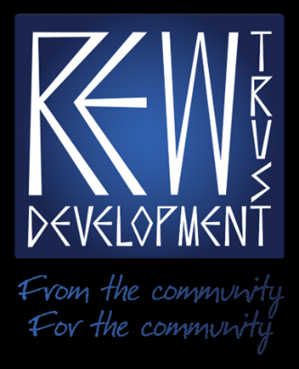
Findings and Outcomes: We looked at the advantages and disadvantages of legal entities for community organisations. These included Unincorporated Associations; Trusts; Company Limited by Guarantee; SCIOs and CICs; Community Benefit Society; Limited Liability Partnerships; and Company Limited by Shares.
A key output was a structured decision-making framework that enabled HIE staff and boards to evaluate priorities such as asset protection, trading risk, governance capacity, and funding eligibility. The guide also highlighted innovative hybrid models linking BenComs with development trusts to enable community share issues while maintaining community accountability.
Benefits: This project delivered a robust, practical toolkit to be used by HIE to strengthen development trusts’ governance and sustainability across Scotland.

Case Study: A Review of the CS Wind Site

Client: Highlands and Islands Enterprise
Project Description: This case study outlines a site review and market assessment of the CS Wind plant in Machrihanish, Scotland, conducted for Highlands and Islands Enterprise. The primary objective was to review the site's potential for sustainable economic growth, given the uncertainty surrounding the future of CS Wind, a key local employer. The study aimed to either identify opportunities to sustain the current company or explore alternative industrial uses for the site to prevent a loss of critical skills and employment in the South Kintyre area.
Method: The project employed a comprehensive review and assessment methodology. It involved a detailed analysis of the CS Wind production capabilities and its position within the onshore wind turbine tower market. The study also included a thorough review of the local economic context, an overview of the skills and workforce issues at the CS Wind plant, and an assessment of the skills base in the surrounding area.
Finally, the team conducted a market potential analysis for alternative industries, including manufacturing and fabrication, onshore aquaculture, renewable energy, and indoor farming, to determine the most viable options for the site.
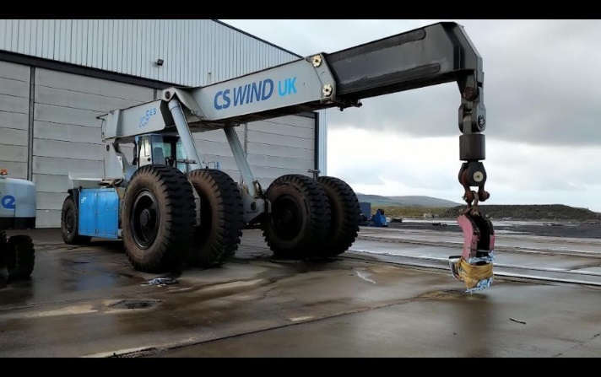
Findings and Results: The assessment revealed that while there are opportunities for CS Wind to diversify its production and remain a key player, this would require a strong commitment from the company. Failing that, the site holds significant potential for new industries to locate and contribute to inclusive economic growth in South Kintyre. The study identified several promising interventions, such as transitioning the site into a renewable energy centre or an indoor farming hub, which could deliver employment and enterprise benefits and ensure the retention of a skilled workforce in the region.
Outcomes: The relationship between CS Wind and Highlands and Islands Enterprise (HIE) became contentious. HIE, which had provided substantial financial assistance to the company, became concerned about the removal of plant and equipment from the site (much of which the review had identified). This prompted HIE to take legal action and successfully secure a court order to prevent the company from removing the equipment. This action was intended to protect HIE's investment and the potential future use of the site for the community. The assets were later marketed for sale by administrators.

